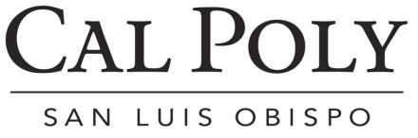

CAL POLY REPORT SUBMISSION
Divisional Approval Form

Cal Poly Report is the university’s official employee newsletter, providing news and listings for events directly related to campus. All events and news items must be sponsored or sanctioned by the university.

All Cal Poly Report submissions must be accompanied by approval from your division’s designated approving authority. Please complete this form and submit electronically with your Cal Poly Report item.

Date of Submission:
Requested Run Date(s):

Submitter’s Name:
Submitter’s Phone:
Submitter’s E-mail:

To be completed by designated approving authority:

I approve the attached submission for inclusion in the weekly Cal Poly Report newsletter.

_________
(Signature)

__________
(Name and Title)

__________
(Date)

